Learning Resources Overview
SunEd High provides our enrolled students and faculty a number of valuable online resources to enhance and support quality teaching, learning, and testing prep. Our students and faculty are able to use these resources to fulfill many of their curriculum needs, which ultimately helps our student’s successfully graduating high school.
We encourage you to review this page, which provides an overview of these resources that students and faculty can access as part of their enrollment benefits in SunEd High.
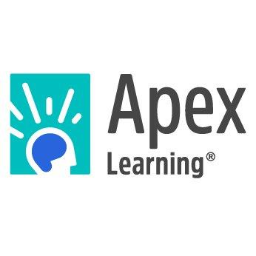

For credit-deficient students, digital curriculum that personalizes learning can be the difference between dropping out and earning a high school diploma. Our Comprehensive Courses provide students who have not been successful in their studies the opportunity to get back on track to graduation.

Alternative Programs
Offer students in non-traditional programs the opportunity to earn the credits required for graduation.

Credit Recovery
Provide each student the opportunity to focus on exactly what he or she needs to master to recover credits.

Dropout Prevention
Motivate at-risk students to stay in school.

Dropout Recovery
Encourage dropouts to re-engage with programs suited to both their learning and life needs.

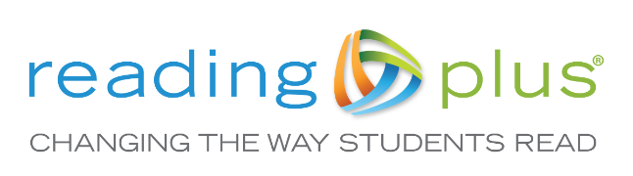
If we want to change what students are capable of reading, we must also change how students read and why students read. To do this requires a comprehensive approach to reading instruction. Reading Plus begins with an assessment that measures a student’s reading capacity as well as his or her reading efficiency and motivation for reading. This allows for personalized and dynamically adjusted instruction that encourages independence, broadens interests, and builds knowledge. Educators easily monitor progress while using the integrated messaging tool to stay in dialogue with students as they experience the success of meeting individualized goals.

Reading Plus simultaneously develops all three domains of reading–physical, cognitive, and emotional–by integrating them in one personalized online reading program. Rooted in eight decades of research, Reading Plus is proven to increase achievement in students from elementary grades through college.

Reading Plus opens the gateway to discovering reading as a source of knowledge, insight, and joy. The result is not just a better reader, but a lifelong reader.

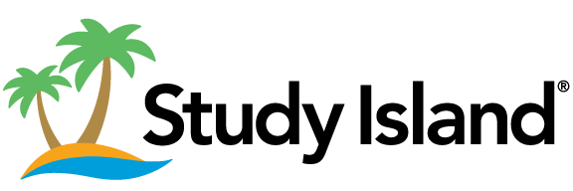

Loved by over 24,000 schools, Study Island supports skill practice and super charges growth. Marzano research has validated that students who use Study Island for just 30 minutes a week far out perform those that do not use Study Island. And, Study Island gives you the tools to monitor your students' performance every step of the way so you can track standards proficiency.

Study Island offers over 600,000 unique items, including more than 10,000 technology-enhanced items, giving teachers the depth needed to continuously engage, assess, and monitor progress.

The Florida Department of Education has made new Florida Assessments for Instruction in Reading available to K- 12 public schools free of charge. Developed by the Florida Center for Reading Research in collaboration with Just Read, Florida!, this new assessment system provides teachers screening, diagnostic, and progress monitoring information that is essential to guiding instruction.

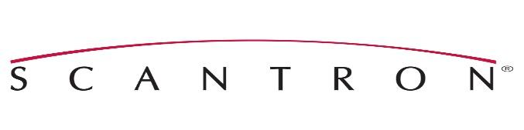
Performance Series®, Scantron’s computer-adaptive diagnostic testing solution, provides educators with instant test results, personalized to each student, that ensure correct overall student placement. Administered over time, these tests provide a longitudinal view of student growth in core curriculum areas (English Language Arts, Mathematics, and Science).

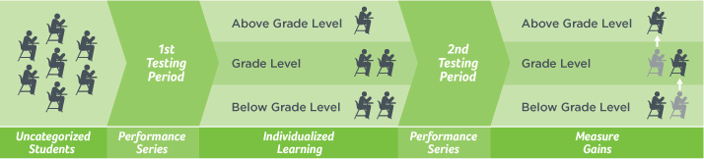

STATE ASSESSMENTS

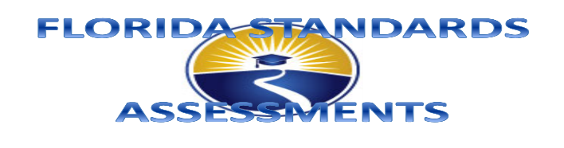
The Florida Standards are the content standards that identify the expectations for what students enrolled in Florida schools need to know and be able to do. The Florida Standards in English Language Arts (ELA) and Mathematics were approved by the Florida State Board of Education (SBOE) in February 2014 and were fully implemented in grades K–12 in the 2014–2015 school year.

All Florida schools teach the Florida Standards. The Florida Standards Assessments (FSA) provide parents and families, teachers, policy makers, and the general public with information regarding how well students are learning the Florida Standards.

FLORIDA STATEWIDE ASSESSMENT PROGRAM
2018–2019 SCHEDULE

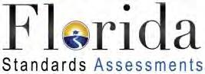 Florida Standards Assessments (FSA)
FSA English Language Arts (ELA) and Mathematics
Dates | Assessment
April 1-12, 2019 | Grades 9–10 ELA Writing
May 1- May 28, 2019 | Grades 9–10 ELA Reading
FSA Retakes
Dates | Assessment
September 10–September 21, 2018 | Grade 10 ELA Writing Retake
September 10–September 28, 2018 | Grade 10 ELA Reading Retake
February 25-March 15, 2019 | Grade 10 ELA Writing Retake  Grade 10 ELA Reading Retake

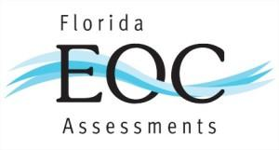

Beginning in 2014-15, assessments aligned to the Florida Standards replaced assessments aligned to the Next Generation Sunshine State Standards in mathematics. The NGSSS Algebra 1 and Geometry assessments were replaced by Florida Standards Assessments (FSA) in these subjects. The NGSSS Algebra 1 Retake EOC will be administered for the final time in Summer 2017. All students completing applicable Algebra 1 or Geometry courses in 2014-15 and beyond will take the FSA End-of-Course Assessment. The science and social studies NGSSS-aligned EOC assessments – Biology 1, and U.S. History – will continue to be administered for students completing applicable courses.

Florida Standards Assessments (FSA)
FSA End-of-Course Assessments
Dates | Assessment
September 10- September 28, 2018  November 26 – December 14, 2018  May 1 – May 28, 2019 | Algebra 1 & Geometry
FSA End-of-Course Retakes
Dates | Assessment
February 25-March 15, 2019 | Algebra 1 Retake

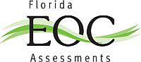

EOC assessments are computer-based, criterion-referenced assessments that measure the Florida Standards (FS) for specific courses, as outlined in their course descriptions. In 2011, Algebra 1 (NGSSS) was the first course to undergo the implementation of a statewide EOC assessment. Over the next few years, it was

followed by Biology 1, Geometry, U.S. History, and Civics, all of which are aligned to the NGSSS.

Beginning in 2014-15, assessments aligned to the Florida Standards replaced assessments aligned to the Next Generation Sunshine State Standards in mathematics. The NGSSS Algebra 1 and Geometry assessments were replaced by Florida Standards Assessments (FSA) in these subjects. The NGSSS Algebra 1 Retake EOC will be administered for the final time in Summer 2017. All students completing applicable Algebra 1 or Geometry courses in 2014-15 and beyond will take the FSA End-of-Course Assessment.

The science and social studies NGSSS-aligned EOC assessments – Biology 1, and U.S. History – will continue to be administered for students completing applicable courses.

Next Generation Sunshine State Standards (NGSSS) Assessments
End-of-Course Assessments
Dates | Assessment
September 10-September 28, 2018  November 26 – December 14, 2018  May 1-May 28, 2019 | Biology & US History

